Olivers Mill
Residents Society

Registered Office: Centre Road, New Ash Green, Longfield, Kent DA3 8HH
www.oliversmill.org.uk enquiry@oliversmill.org.uk

Special Newsletter
Coronavirus Covid-19 is the number one talking point at the moment and there is plenty of information about this in the news. Here is some information about how the residents can access some support during these times of uncertainty.

Asking for help or Offering help
Sevenoaks District Council (SDC) have set up a registration system and are working with a new, local organisation called ‘Care in our Community’, which is based on social media.
If you are able to offer help locally, please contact SDC to register your details. These details will then be passed to ‘Care in Our Community’ and a local volunteer will be in touch with you to find out what sort of help you can offer.
IF YOU NEED HELP – Please register with Sevenoaks District Council. They will pass your details on to ‘Care in our Community’. Then a local volunteer will be in touch with you to match your needs with a registered volunteer who can help you.
Registration for help or to offer help can be made online at www.sevenoaks.gov.uk/requesthelp or by telephoning 01732 227000.
We have at least two registered volunteers already on Olivers Mill, so you can be assured that if you need help, you will receive it.
Help can be given to anyone who is senior or in a vulnerable category, or deem themselves to be vulnerable and also for anyone who is self-isolating either because they are unwell, or for preventative measures. The type of help that can be given can include:
- Picking up and delivering prescriptions
- Picking up and delivering some groceries/supplies
- Providing care for your animal, such as walking your dog
- Providing information on the telephone for those who do not have internet access
If the help you need is not listed here, please still register with Sevenoaks District Council as it may be that the help you need can still be provided.
Volunteers will NOT ask for cash or for your PIN for your bank card. Please contact Sevenoaks District Council for more information about this scheme.

Toilet Paper
Although the information being shared by the major suppliers is that toilet paper is NOT in short supply, there has been a significant increase in the amount of toilet paper that is being bought at the moment. If you do find yourself using alternatives to toilet paper (such as kitchen roll, newspaper or fabric), PLEASE DO NOT FLUSH THIS DOWN THE TOILET. These materials will not break up like toilet paper does and it will clog and block the drains quickly and this could cause a major problem inside our homes and gardens.
Food deliveries
It has been reported that arranging food delivery from the major supermarkets is proving to be quite difficult due to high demand. Here are a couple of local organisations who may be able to help you during this time. Please note that these are not endorsed by Olivers Mill Residents’ Society, it is purely shared information.
I have been in touch with a local supplier Watts Farms, who are delivering food boxes for £26, including delivery. Details of the delivery boxes are below:
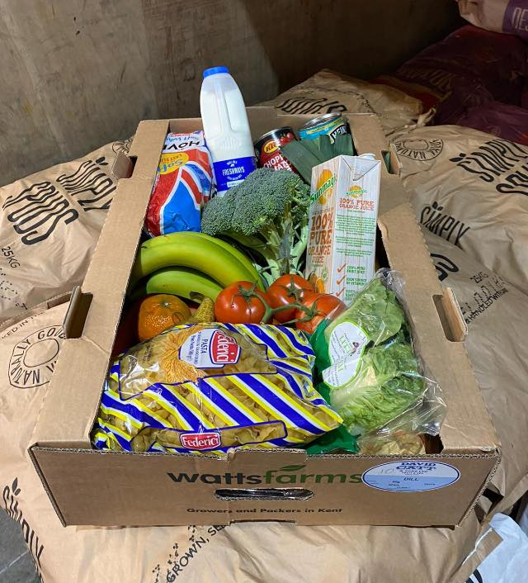  I have been advised that delivery to Olivers Mill could be on a Wednesday or a Friday.  The earliest delivery date for Olivers Mill is Friday March 27th and that could be pushed into the following week as they are very busy. Priority will be given to elderly, vulnerable and those who are self isolating.  Please make your telephone call as soon as possible to reserve your box. 07960 687205 | This is an example of the delivery box:  1ltr orange juice  1 loaf white bread  2ltr semi skimmed milk  500g pasta  1kg white potatoes  500g broc  4 carrots  2 white onion  3 bananas  3 satsuma  2 apples  2 pears  6 eggs  400g tin chop Tom  400g tin baked  1 punnet grape  2 leeks  1 packet little gems lettuce  1 vine tomatoes  250g mushroom  1 block butter  1 cucumber  1 box of mixed salad  I’m selling them for £26 ( delivered ) can’t do any less as we are picking stuff up from all over Kent.  If you need or know anyone who does please pm myself (Simon Evans) or Ben Lewis on 07960 687205
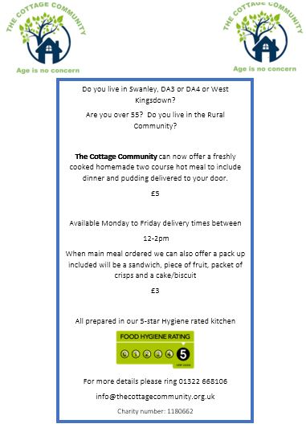 | And finally…..  Please remember to be as neighbourly as possible during these next few months. Many neighbours will be home all day.  With so many of us needing to find ways to get through isolation, it is great to have fun when you can and get jobs done. Please just be mindful of the hours that you will be doing DIY, having barbeques or playing loud music. We all need to live together and a little consideration goes a long way at times like this. And if you have neighbours that you think might be vulnerable, perhaps just check in with them by text or phone every so often.  If you need to get in touch with the Residents’ Society, please continue to use the contact page on the website www.oliversmill.org.uk or email directly enquiries@oliversmill.org.uk

